Cam Newton YouTube Strategies

I initially joined Cam as a freelance editor in 2021. At that time, the channel uploaded the Funky Friday podcast on occasional Fridays, along with random vlogs and videos from C1N (Cam’s Youth Football team) tournaments. My first project was editing a [Space Jam premiere vlog](https://www.youtube.com/watch?v=4ZfgjQDGZRo). Shortly after, I began editing full podcast episodes, thumbnails, C1N episodes, and more. However, it wasn’t until 2022, during a team retreat, that I became heavily involved in leading the YouTube strategy.

### **The Turning Point**

At the retreat, I presented ideas to the team:

* The importance of consistent uploads
* Clear thumbnail strategy
* Leveraging Shorts
* Identifying channel genres to pursue
* Repurposing old footage
* Incorporating regular team brainstorms

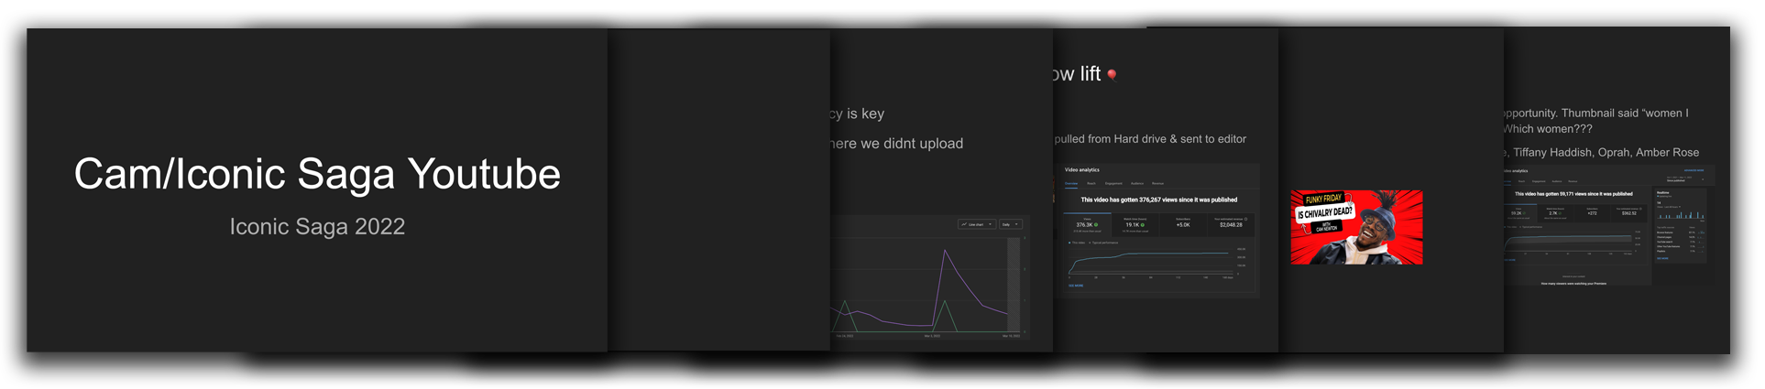

This presentation became pivotal. Afterward, Cam and I went through each slide in reverse order to dive deeper into the topics. He recognized the value of the strategies, which led to me becoming the unofficial leader of YouTube strategy while still managing editing responsibilities.

A memorable moment from this retreat was a $1,200 bet with Cam, where I jumped into a freezing swimming pool. This team was just different, and one of the reasons I LOVED this job.

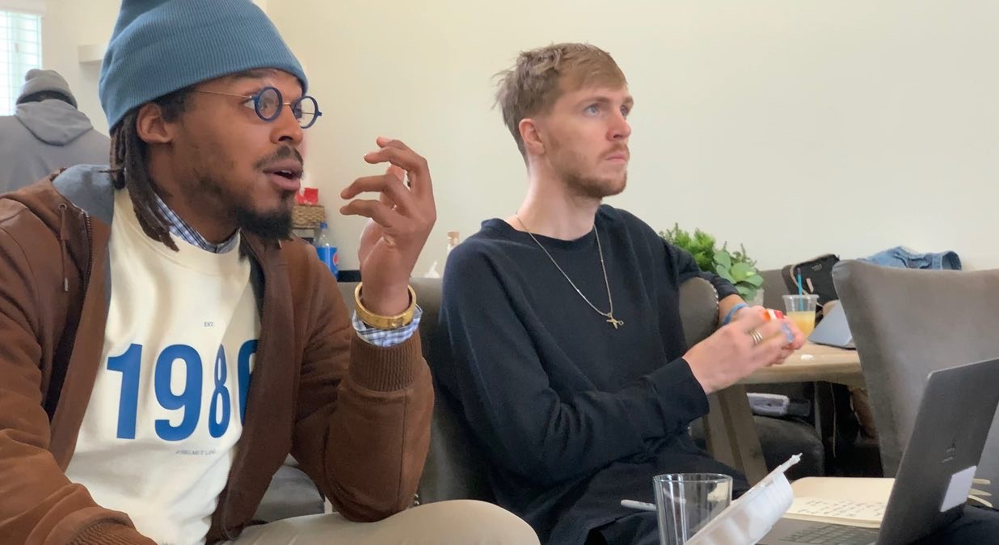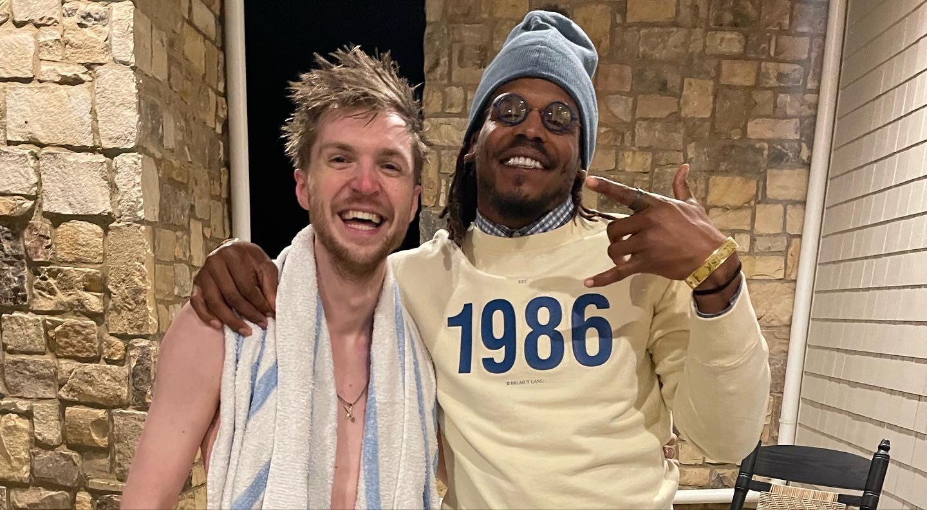

### **Strategic Shifts and Measurable Outcomes**

**Thumbnail Overhaul:**

* Developed a new thumbnail strategy to increase CTR:
  + Used expressive faces, darkened hair, brightened teeth, and sharpened eyes.
  + Implemented A/B testing manually (pre-YouTube’s built-in feature).
  + Created a thumbnail face database to maximize consistency.
  + Results:
    - CTR increased from 5-8% to over 10%, sometimes surpassing 14%.
    - Videos using new thumbnails generated $5,968 more revenue per video compared to older designs.

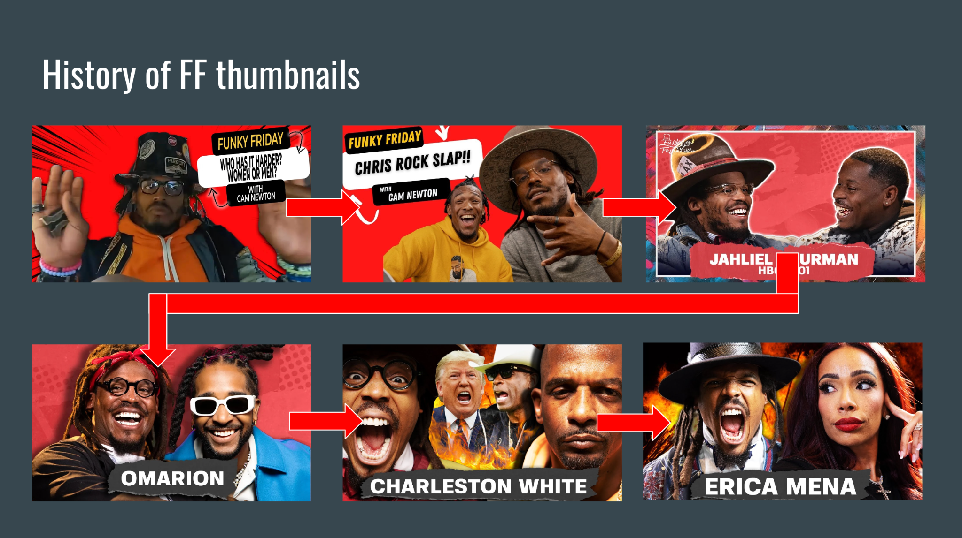

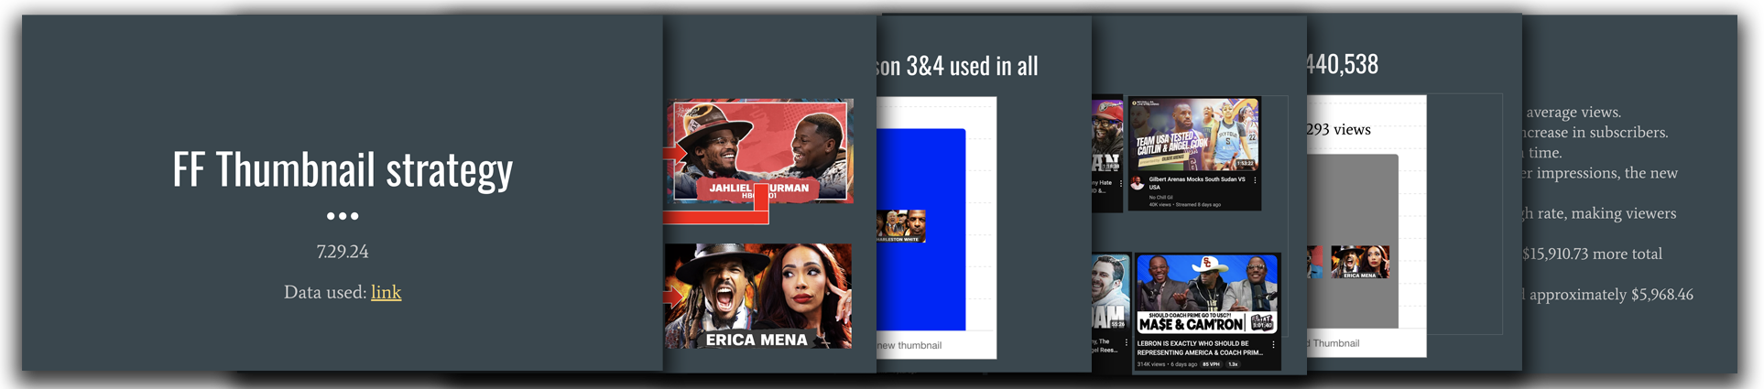

**Clips and Shorts Optimization:**

* Recognized clips as a growth engine:
  + Uploaded clips exceeding eight minutes to hit extra ad thresholds, boosting revenue significantly.
  + Crafted enticing opening sentences to increase Average View Duration (AVD).
  + Shorts became a top-of-funnel driver, with 330,769 subscribers gained in the past year.
  + Results:
    - AVD for clips reached 39.9%.
    - Shorts contributed nearly 50% of total subscriber growth.

**Content Tailored to Audience Insights:**

* Applied audience avatars derived from 2024 VidSummit learnings:
  + Mike Johnson: A 32-year-old sports enthusiast in Dallas who values bold, unfiltered conversations.
  + Maya Turner: A 29-year-old marketing coordinator in Atlanta drawn to emotional and self-growth topics.
* Results:
  + By aligning content with audience demographics, we increased returning viewer rates, particularly for videos featuring bold debates and high-profile guests.

**Long-Form Podcast Growth:**

* Experimented with longer podcast episodes:
  + Extended average runtime to over two hours.
  + Introduced pre-intros featuring best one-liners to hook viewers early.
  + Results:
    - Monthly revenue **more than doubled**.
    - Pre-intros added approximately **five minutes to AVD**.

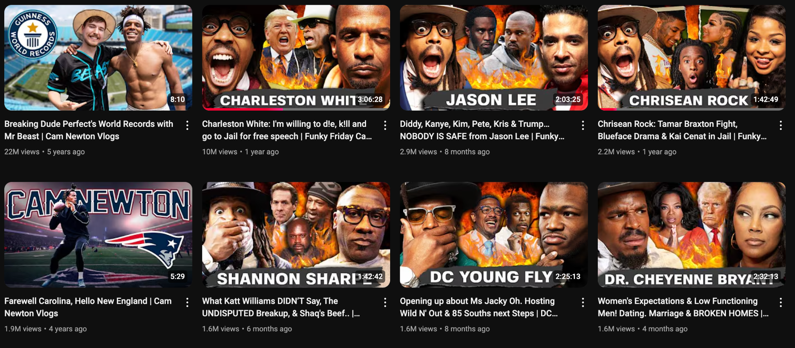

**Vertical Content Excellence:**

* Built a dedicated vertical team, nicknamed “Vertical Bois,” to produce Shorts and Reels.
  + Held weekly meetings rewarding the best vertical with a $10 incentive.
  + Avoided overt cross-promotion, focusing instead on high-quality verticals.
  + Results:
    - YouTube Shorts generated 233,583,482 views in 2023 and 2024
    - AVD for Shorts reached 99.3%, showcasing exceptional engagement.

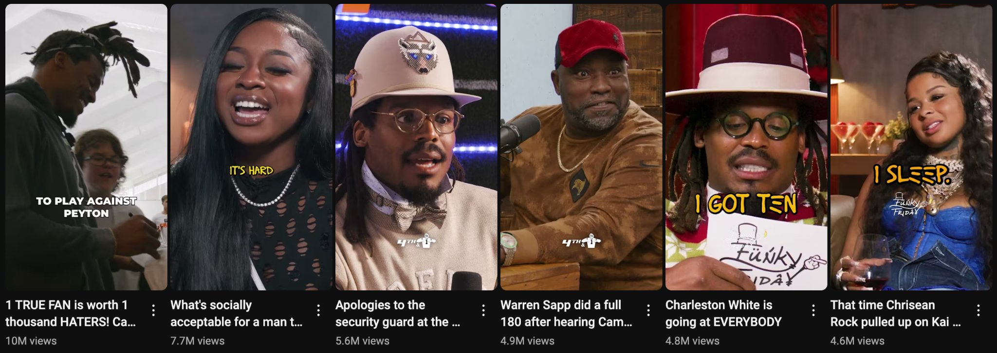

### **Organizational Leadership**

In early 2023, I officially became YouTube Director. This allowed me to:

* Launch structured testing, leveraging data to refine strategies.
* Improve team workflow by:
  + Delegating responsibilities effectively.
  + Establishing timelines to prevent burnout.
  + Creating a collaborative culture through brainstorms and clear goals.

By late 2023, we restructured the company, and I also became Director of Post-Production, overseeing three YouTube channels averaging over 50M views monthly across platforms.

### **Highlights**

My first YouTube video to hit 10M views. Cam Newton interviewed Charleston White which became the biggest ever episode of Funky Friday

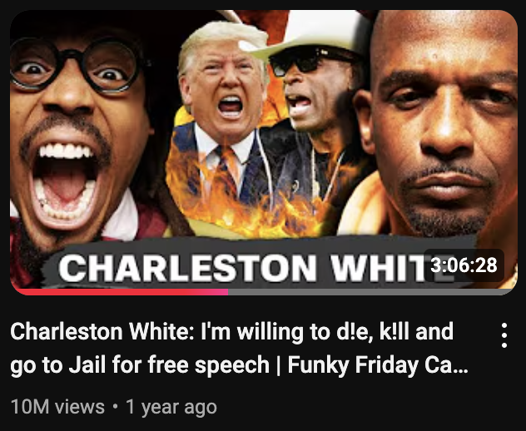

### **Conclusion**

Leading Cam Newton’s YouTube strategy has been a journey of creative innovation, data-driven decisions, and team collaboration. From improving thumbnails to leveraging audience insights, these efforts have resulted in exponential growth for the channel. With a clear vision and the right team in place, we’re poised to reach even greater heights in the digital content space.